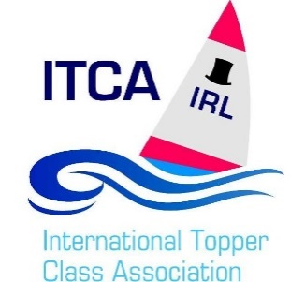

Ireland 26/11/2018

Advertisements will be hosted in the Adverts on the Topper Ireland website page free of charge and are subject to the following conditions.

• Adverts will be hosted for a maximum of 60 days, however once this period has passed the advertiser has the opportunity to continue advertising, but it will require validation.

• Only adverts which advertise the Topper Dinghy or other relevant items such as support ribs, trailers or equipment will be allowed on the website.

• Adverts should contain an accurate honest description of the item, a price and images if applicable.

• All adverts will be subject to be edited or deleted as seen fit by the current webmaster.