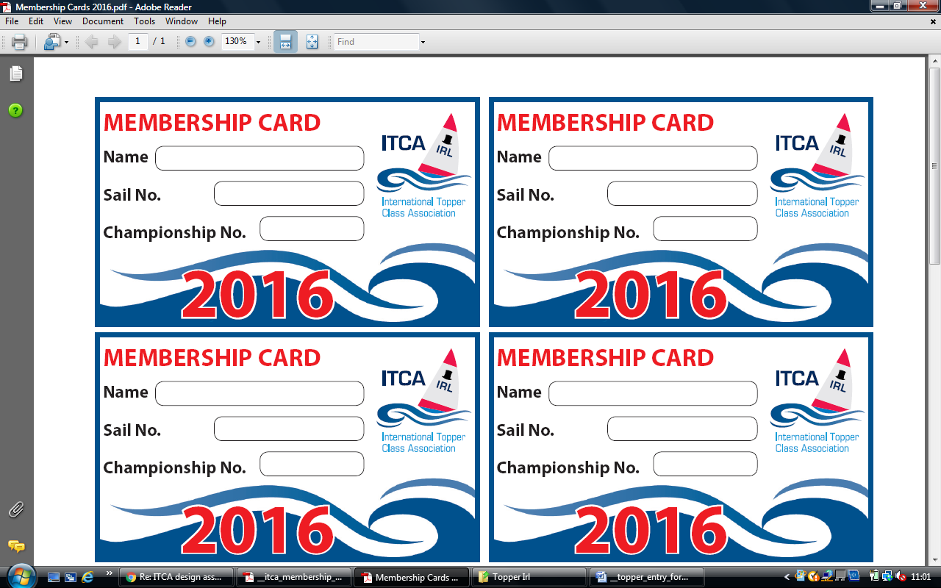**ITCA (IRL) Fees/Age groups**

The following tables provide fees and age classifications for Topper Year.

**This is the definitive source of information and all other documents should use it as their reference.**

|  |  |  |  |
| --- | --- | --- | --- |
| **Category** |  | | **Notes** |
|  | | | |
| **Membership Fees** |  | |  |
| Yearly Membership*¹ | **€30** | | January to December  Note this is required to retain and or be allocated a Championship Number |
| For any event that take place over more than 1 day*² competitors must be yearly members of a Topper Class Association (ITCA) this includes international events  *¹For some events including the British Nationals and the Topper Worlds, a championship number is required, to obtain a championship number you must be a yearly member of the Irish Topper association.  *² the exception to this rule is for two-day sprints where daily members is allowed | | | |
|  | **£** | **€** |  |
| Daily Event Membership | 6 | 7 | Price per event;  not available for 2-day, Irish Nationals or international events. |
|  | | | |
| **Event Fees** |  |  |  |
| 1 Day Event Entry | 25 | 30 |  |
| 2 Day Event Entry | 40 | 50 |  |
| 3 Day Event Entry | 60 | 70 |  |
|  | | | |
| **Capitation Fees** |  |  | Taken from the Entry fee |
| 1 Day Event Entry | 4 | 5 |  |
| 2 Day Event Entry | 6 | 7 |  |
| 3 Day Event Entry | 6 | 7 |  |

**Capitation Fees** are the stated fee due to the Ireland Topper Class Association for each entry received by the host club. This fee is due within 2 weeks of the closing on the event.

|  |  |
| --- | --- |
| **Junior**  Under 14 | Under 14 year of age before the 1st January this year |
| **Youth**  Over 14 | Over 14 years of age on or after 1st January this year |